Parallel Programming Exercise 5-11

Author: | 梁瑞恩 (r11922201@ntu.edu.tw)
Student ID | R11922201
Department | CS
(If you and your team member contribute equally, you can use (co-first author), after each name.)

Problem and Proposed Approach
(Brief your problem, and give your idea or concept of how you design your program.)
利用
MPI_Bcast(&n,1,MPI_INT,0,MPI_COMM_WORLD);
MPI_Bcast(&d,1,MPI_INT,0,MPI_COMM_WORLD);
兩個 Bcast 向所有processer 傳送 n 跟 d 來達到廣播效果，
所有process分工作，每個processor做約 n/p個 數量
for(i = id+1; i <= n;i+= p)
{
frac = (double) 1 / (double) i;
ans += frac;
}
MPI_Reduce(&ans,&global_solution,1,MPI_DOUBLE,MPI_SUM,0,MPI_COMM_WORLD);
用 MPI_Reduce 將所有process的ans 加入 global_solution中，由 id 0 的processor輸出

Theoretical Analysis Model
(Try to give the time complexity of the algorithm, and analyze your program with iso-efficiency metrics)
Serial Time complexity: theta(n) ;
Parallelism iso-efficiency : theta(n/p)

Performance Benchmark
(Give your idea or concept of how you design your program.)

 | Sequential execution time | 0.000039 | 0.000039 | 0.000039 | 0.000039 | 0.000039 | 3.9E-05 | 0.000039 | 0.000039
 | Processors | 1 | 2 | 3 | 4 | 5 | 6 | 7 | 8
 | Real execution time | 0.000039 | 0.000069 | 0.000092 | 0.000086 | 0.000052 | 0.00006 | 0.000052 | 0.000039
 | Speedup | 1 | 0.565217 | 0.423913 | 0.453488 | 0.75 | 0.65 | 0.75 | 1
 | Karp-flatt metrics | #DIV/0! | 2.538462 | 3.038462 | 2.606838 | 1.416667 | 1.64615 | 1.388889 | 1
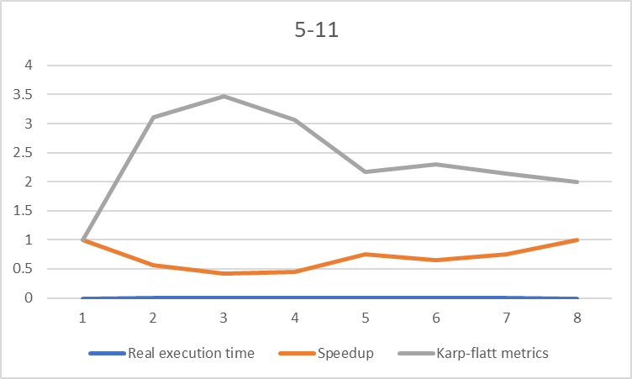

Figure 1. The performance of diagram

Conclusion and Discussion
(Discuss the following issues of your program
- What is the speedup respect to the number of processors used?
- How can you improve your program further more
- How does the communication and cache affect the performance of your program?
- How does the Karp-Flatt metrics and Iso-efficiency metrics reveal?
)

Appendix(optional):
(If something else you want to append in this file, like picture of life game)

